**CENWP-ODJ2/07/2023**

**MEMORANDUM FOR THE RECORD**

**SUBJECT: *23JDA02 Submersible Traveling Screen (STS) Oil Leak***

On the morning of February 6th 2023 at 0815, a Submersible Traveling Screen (STS) was removed from a stored location in the STS slot at 1C. The crane moved the STS over the roller gate slot then proceeded to travel along the roller gate slot from 1C and moved north to slot 15C.  After arriving at slot 15C an oil leak had been discovered and an oil sheen was visible.  After further investigation, oil was found in the path of travel from slot 1C through slot 15C.  It has been determined the oil leak is coming from the STS gear box system out of the accumulator tank.  The failed STS has been moved into the STS repair pit for further investigation and will be repaired with spare parts on hand.

Complete cleanup of all oil from Slots 1C to 15 C was immediately underway. The oil capacity for the gear box system is 9.75 gallons.  Initial collection of oil accounted for at least 5 gallons, and by 1624 that afternoon 8 gallons of oil had been recovered from the accumulator on the STS. The amount of oil soaked up by pads is to be determined and not included the 8gallon amount. The estimated amount of oil that leaked into the waters of the gate slots is approximately one (1) cup. The gear box was last inspected 3 DEC 22 and is thought to be original equipment.

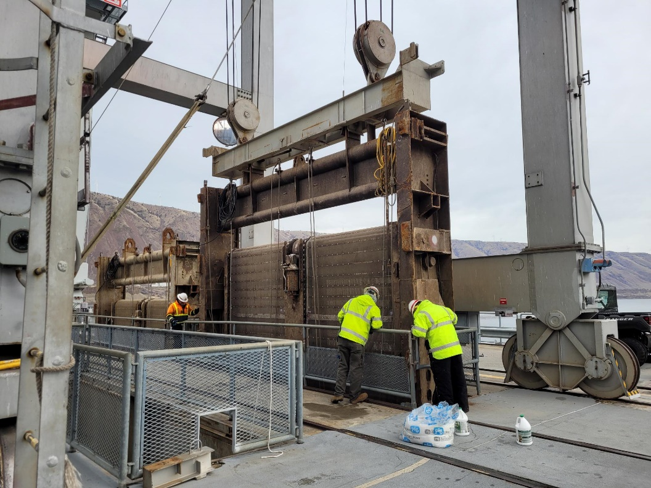

1. Species – NA
2. Origin – NA
3. Length – NA
4. Marks and tags – NA
5. Marks and Injuries found on carcass – NA
6. Cause and Time of Death – NA
7. Future and Preventative Measures – Monitor during winter maintenance periods.

Sincerely,

Project Fisheries